- Variable Declaration Rule in C++
To Declare any variable in C++ you need to follow rules and regulation of C++ Language, which is given below;
- Every variable name should start with alphabets or underscore (_).
- No spaces are allowed in variable declaration.
- Except underscore (_) no special symbol are allowed in the middle of the variable declaration.
- Maximum length of variable is 8 characters depend on compiler and operation system.
- Every variable name always should exist in the left hand side of assignment operator.
- No keyword should access variable name.
Note: In a c program variable name always can be used to identify the input or output data.
Variable declarations
This is the process of allocating sufficient memory space for the data in term of variable.

Syntax
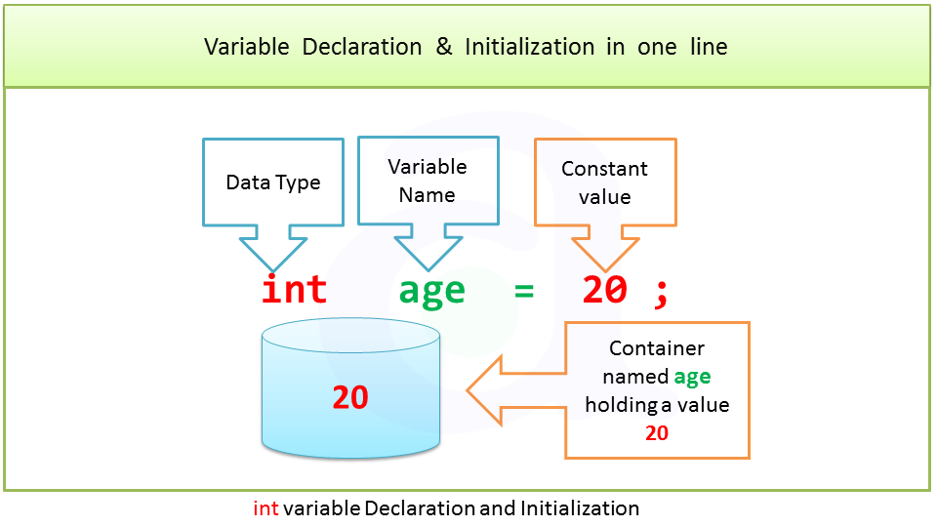

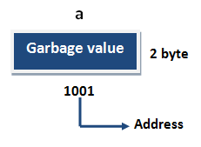 | If no input values are assigned by the user than system will gives a default value called garbage value.

#include <iostream>
using namespace std;

int main() {
int num = 15;
cout << num;
return 0;
}

- Class Declaration Rule in C++

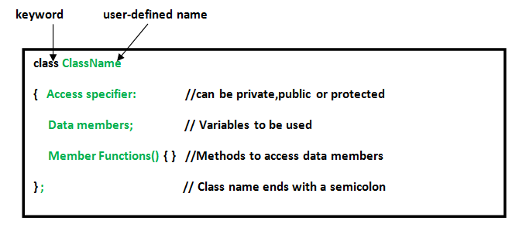

- Type class keyword then space and type class name
- Type curly brackets {}
- Type semicolon at the end of curly brackets
Syntax:
class Durgesh
{};

3. Functions Declaration in C++
Basic Syntax for using Functions in C++

return-type function-name(parameter1, parameter2, ...)
{
// function-body
}
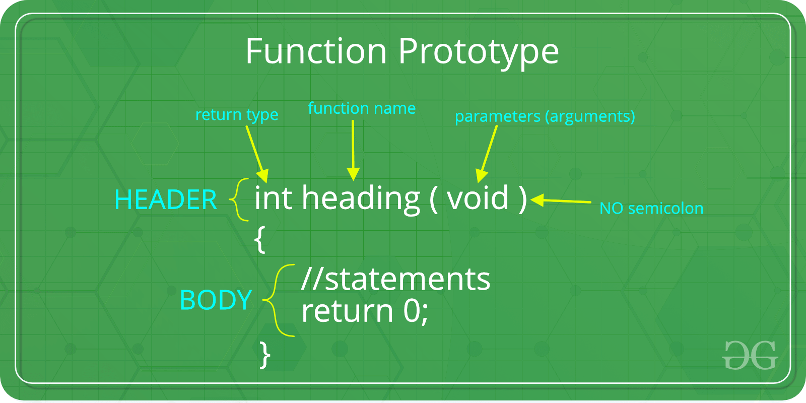
- return-type: suggests what the function will return. It can be int, char, some pointer or even a class object. There can be functions which does not return anything, they are mentioned with void.
- Function Name: is the name of the function, using the function name it is called.
- Parameters: are variables to hold values of arguments passed while function is called. A function may or may not contain parameter list

// function for adding two values
void sum(int x, int y)
{
int z;
z = x + y;
cout << z;
}

int main()
{
int a = 10;
int b = 20;
// calling the function with name 'sum'
sum (a, b);
}
- Function body: is the part where the code statements are written.

4. Constructors Declaration Rule in C++
What is constructor?
A constructor is a member function of a class which initializes objects of a class. In C++, Constructor is automatically called when object of class create. It is special member function of the class.
Rule
- Constructor has same name as the class itself.
- Constructors do not have return type.
- A constructor is automatically called when an object is created.
- If we do not specify a constructor, C++ compiler generates a default constructor for us (expects no parameters and has an empty body).
constructor types in c++
